Speaker Information

Colleen Elio-Kocen, M.A., is the Medical and Campus Advocate, at Transitions. She is the point person for the SANE program. She also provides counseling for students at Susquehanna University and works extensively with victims of human trafficking throughout our service area.

Joshua Ercole, is the Chief Operating Office of the Council on Compulsive Gambling of Pennsylvania.

Kristi Conrad, MS, is a clinical supervisor at Gaudenzia Outpatient program in Sunbury. She also works part time with adults with Alzheimer’s Disease.

Corporal Scott M. Davis, Pennsylvania State Police, is a Patrol Trooper, Undercover Drug Investigator, Law Enforcement Instructor and Drug Recognition Expert.

This training is funded by:
PENNSYLVANIA
DEPARTMENT OF HEALTH
DEPARTMENT OF DRUG AND
ALCOHOL PROGRAMS-Problem Gambling Outreach Mini Grant

COLUMBIA/MONTOUR
AGING OFFICE, INC.

UNION-SNYDER
AGENCY ON AGING, INC.

CMSU BEHAVIORAL HEALTH SERVICE

Program Objectives

At the conclusion, participants will be able to:
- Describe trauma-informed and person-centered interview methods
- Identify behaviors that may be signs of a history of sexual assault or domestic violence
- Understand how to refer an older adult or individual with a disability to victims’ services
- Understand barriers to effective screening for sexual assault and domestic violence
- Understand statistics for addiction in the elderly
- Identify signs and symptoms of addiction
- Identify addiction and mental health in the elderly
- Understand addiction and gambling in the elderly
- Understand the role of MAT in the elderly
- Understand the role of families and addiction
- Know where and how to get help
- Become familiar with gambling and factors included in the development of problematic gambling, specifically among older adults
- Identify prevalence rates and risk factors of disordered gambling
- Discuss warning signs and how to address gambling issues with older adults
- Identify ways to maintain responsible levels of gambling participation
- Have awareness of available local gambling resources
- Understand general indicators to look for when dealing with someone under the influence
- Identify drug trends currently taking place in Pennsylvania

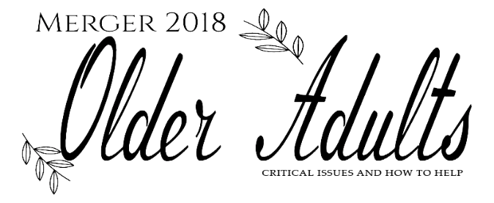

June 22, 2018

Country Cupboard
101 Hafer Road
Lewisburg, PA 17837

SPONSORED BY:
Columbia/Montour Aging Office, Inc.
CMSU Behavioral Health Services
Union-Snyder Agency on Aging, Inc.

CO-SPONSORED BY:
Institute for Social Work Research, Education, and Consultation School of Social Work, Marywood University

Directions or Hotel Information:
Melissa at (570) 523-3211

Conference Registration Information:
Christine Pritchard at (570) 784-9272

We welcome you to join us at our 2018 Merger conference. This conference is specifically designed for those professionals who work to address the behavioral health needs of the older adult living in the community. Mental Health and Aging staff throughout our state have been collaborating to share resources and knowledge in order to improve services to our older adults. We agree to strive to meet the needs of the older person with mental health issues with a new focus on recovery.

This conference is intended to refresh us as we work towards merging our abilities. Through caring, understanding and knowledge, we can continue to grow personally and professionally, touching the lives of those we serve as well as those who serve with us.

Join us for this fun day filled with great speakers, good food, networking and important information that will help you personally and professionally.

Continuing Education Credits
Marywood University School of Social Work, an approved provider, is providing 4.5 hours of continuing education credits for social workers, applicable toward PA/LSW licensure renewal.

Program Agenda

7:45A.M.-8:15A.M.: Registration

8:15A.M. -8:30A.M. Welcome-Danielle Crane-King, Union/Snyder Area Agency on Aging

8:30 A.M.-10:00 A.M. Person-Centered Screening for Older Adults and Individuals with Disabilities

10:00A.M.--10:15 A.M. Break

10:15A.M.-11:30A.M. Gambling Disorder and Older Adults

11:30A.M.-1:00P.M.: Networking Lunch
(Room needs to be cleared from 11:30am to 12 noon for set up.)

1:00P.M.-2:00P.M. Substance Use Disorders and the Elderly

2:00P.M.-2:15P.M. Break

2:15P.M.-3:30P.M. Drug Training Program

3:30P.M.-3:35P.M. Closing/Evaluations

(Due to air conditioning a sweater is recommended)

There is no registration fee but advance registration is required. Space is limited and registrations will be accepted on a first-come, first-served basis. Training materials, certificate of attendance, continental breakfast and lunch will be provided.

Please submit registrations no later than June 11, 2018 to:

Christine Pritchard, Protective Services Supervisor
Columbia-Montour Aging Office, Inc.
702 Sawmill Road, Suite 201
Bloomsburg, PA 17815
570- 784-3678 (FAX)

CONFIRMATIONS WILL NOT BE SENT!

Registration and Contact Information:
NAME: __________________________________
AGENCY: ____________________________________
ADDRESS: ____________________________________
____________________________________
PHONE: ____________________________________

E-Mail:_____________________________

